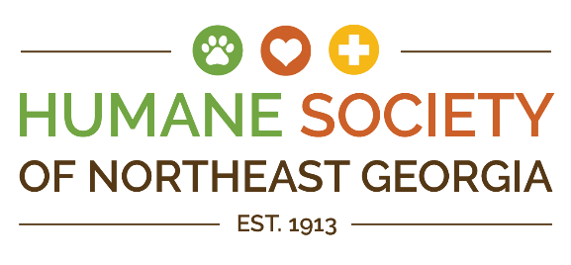

**Humane Society of Northeast Georgia**

**845 W Ridge Rd Gainesville, Ga 30501, 770-532-6617, www.HSNEGA.org**



**POSITION:**  **Associate Veterinarian**

**REPORTS TO:** Vice President of Veterinary Services

**SALARY:** $120,000

**GRADE LEVEL:** New graduates are encouraged to apply. This position will be working with two experienced full time veterinarians able to provide mentorship

**HOURS:** 32 hours weekly as a combination of four eight hour shifts Tuesday to Saturday. This position may have varying working hours including the ability to work nights, holidays and weekends as needed. Availability by phone may be required after hours for emergencies.

**BENEFITS:** Health, vision and dental insurance, paid holidays, 401K, employee assistance program

Eligible for public service loan forgiveness (PSLF)

Paid CE, licensing, and DEA registration

Paid time and allowance for CE travel

120 hours of PTO/year plus sick leave (graded by length of employment)

**CLASS:** Full-time, exempt

**Summary:**The Associate Veterinarian provides high-quality medical and surgical care for both shelter and public animals at HSNEGA's adoption center and Healthy Pet Clinic. This role includes leading and coaching the Veterinary team to ensure efficient, high-volume, low-cost wellness services for public animals and top-tier care for shelter animals.

**Responsibilities:**

* **Surgery:** Perform 20-30 spay/neuter surgeries daily using HSNEGA’s standardized techniques. Handle more complex surgeries as needed, and oversee all aspects of surgical care, including pre-op, anesthesia, and post-op monitoring.
* **Shelter Medicine:** Assess and treat shelter animals, collaborating with the Veterinary Services team to create and implement care plans. Stay updated on shelter animal health protocols and manage complex medical cases.
* **Wellness Services:** Conduct exams, vaccinations, and basic procedures for owned pets in a high-volume setting. Educate pet owners on affordable care solutions, and ensure efficiency of the Veterinary Care team.
* **Other Duties:** Assist in developing SOPs, training staff, and occasionally perform off-site spay/neuter surgeries with the Better Together Georgia statewide shelter outreach program.

**Qualifications:**

* DVM, VMD, or equivalent with a valid veterinary license.
* Strong communication, interpersonal, and decision-making skills.
* Commitment to compassionate, patient-centered care and the mission of HSNEGA of helping pets and people live better… together.
* Ability to work in a fast-paced, high-volume environment, including standing for long periods and handling animals.

**Working Conditions:**

* Work in an animal welfare facility with potential exposure to zoonotic diseases, hazardous materials, and allergens.
* Ability to lift up to 50 pounds, stand for extended periods, and handle animals.
* Flexibility to work beyond scheduled hours when needed.